**AI Based Personal Virtual Assistant**

Course Name: Artificial Intelligence Lab

Course Code: CSEL-4102

## **Submitted By**

## Team Name: Team Fix_it

## MD. Tanvir Ahammed Hridoy

ID: B180305020

## Susmita Rani Saha

## ID : B180305047

## 

## **Submitted To**

## Tanvir Ahammed

## Lecturer

## Department of computer Science and Engineering,

## Jagannath university



Department of computer Science and Engineering,

Jagannath university

Contents

Introduction 3

Motivation 4

Workflow Diagram 4

Project Demonstration  5

Result Analysis  7

Limitations 7

Project GitHub Link 7

Conclusion 7

References 8

* **Introduction:**
* Virtual Assistant – AI-based personal voice assistants as intelligent software applications that use artificial intelligence and natural language processing techniques to understand and respond to human voice command
* Virtual Personal Assistant carry out all the tasks that are too complex for you on a daily basis.
* Natural Language Processing – a subfield of computer science, concerned with the interactions between computers and human (natural) languages.
* Popular virtual assistants - Amazon Alexa, Apple's Siri, Google Now and Microsoft's Cortana

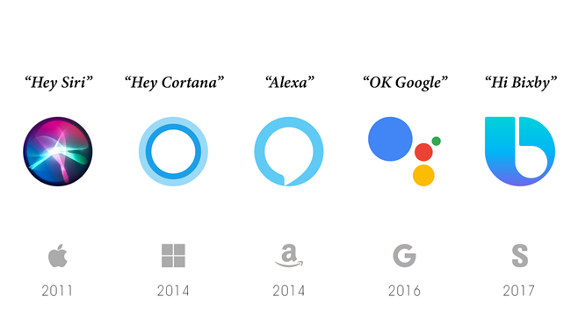

* **Motivation:**

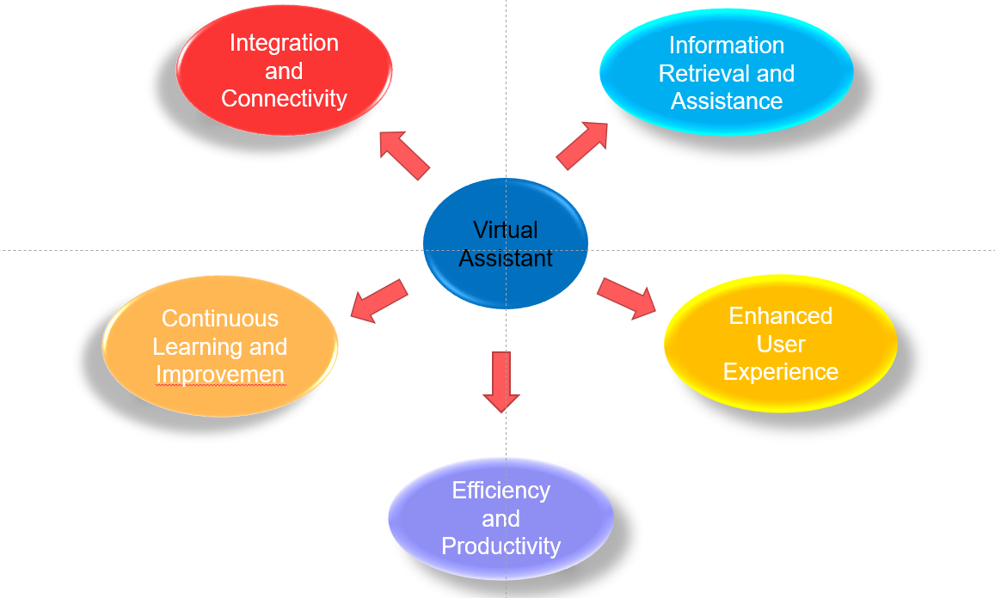

* **Workflow Diagram:**

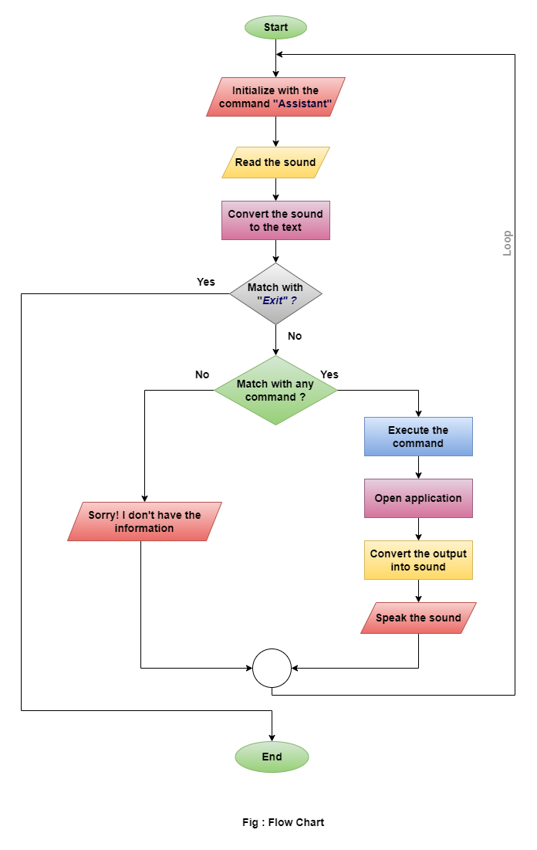

* **Project Demonstration** :

Its helps to operate our computer much easier way by giving the command. It can do app opening, weather report, take note, time, jokes, google search, news, email and many things like that.

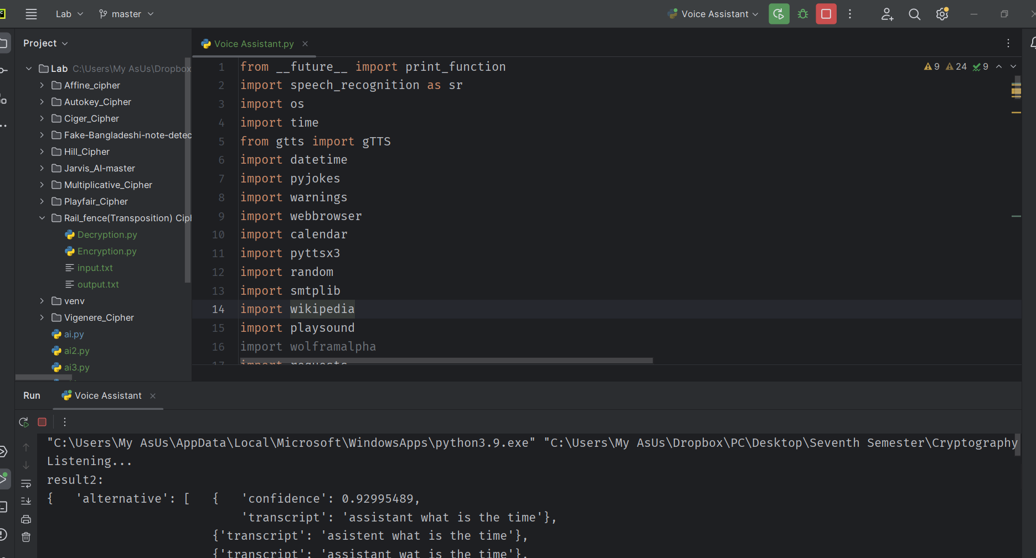

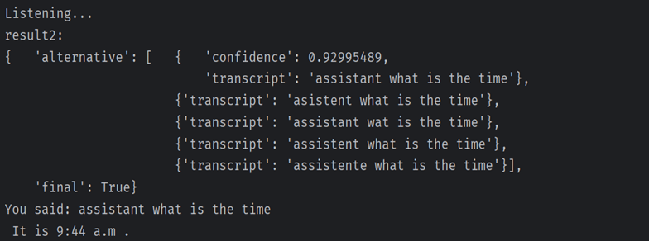

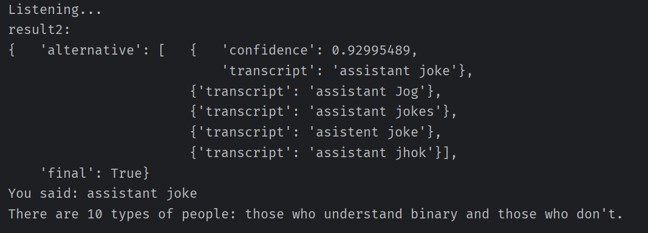

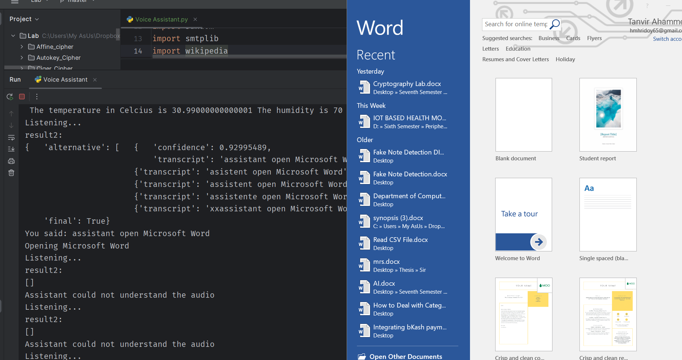

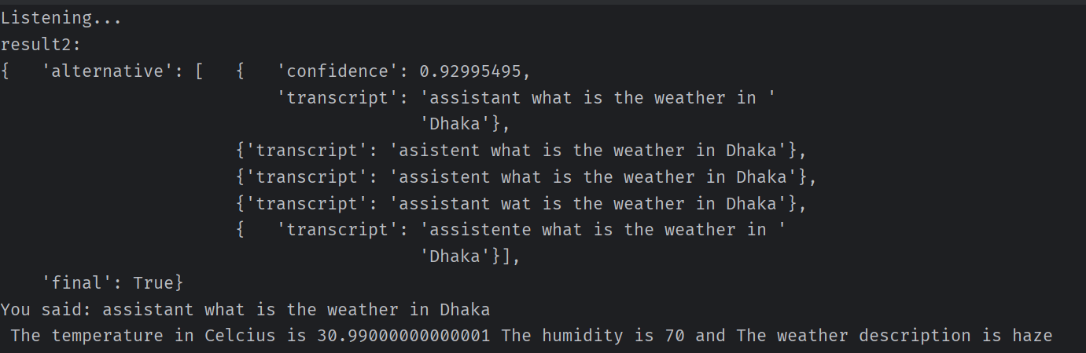

* **Result Analysis:**

We want to calculate the performance or accuracy of our project, so we calculate the number of correct and incorrect word detection from our speech.

|  |  |
| --- | --- |
| **Total Number of Test** | **50** |
| **Correct Detection** | **42** |
| **Incorrect Detection** | **08** |
| **Accuracy** | **84%** |

* **Limitations:**

We saw that there are 16% incorrect detection of our word which we command by speech. The main problem is that the surroundings noise and the microphone quality of the computer. If we had better microphone which support noise cancellation the performance can be improved.

* **Project GitHub Link:**
* [**https://github.com/Tanvir180/AI_Based_Personal_Virtual_Assistant**](https://github.com/Tanvir180/AI_Based_Personal_Virtual_Assistant)
* **Conclusion:**

A virtual assistant is an intelligent software application or program that uses artificial intelligence (AI) and natural language processing (NLP) techniques to understand and respond to user commands and queries. It is designed to simulate a conversation or interaction with a human assistant, providing assistance, information, and performing tasks based on user input.

* **Reference:**
* Lugano, Giuseppe. "Virtual assistants and self-driving cars." 2017 15th International Conference on ITS Telecommunications (ITST). IEEE, 2017.
* Mekni, Mehdi. "An artificial intelligence based virtual assistant using conversational agents." *Journal of Software Engineering and Applications* 14.9 (2021): 455-473.
* Gubareva, Regina, and Rui Pedro Lopes. "Virtual Assistants for Learning: A Systematic Literature Review." *CSEDU (1)* (2020): 97-103.
* YouTube
* Google